SDG&E’s comments on CAISO’s Proposed Revision Request 1280
Submitted by | Company | Date Submitted
Nuo Tang  858.654.1818 | San Diego Gas & Electric | September 16, 2020

In reviewing the CAISO’s proposed changes, SDG&E believes the changes to the business practice manual goes beyond the intent of the slow demand response initiative as noted by CAISO staff to the Board of Governors on July 22, 2020. Instead of limiting the change to slow demand response resources in the Local area, the CAISO’s proposed language allows the CAISO to reject any credits that would impact the supply or RA requirement even if it’s not related to the slow demand response resources in the local area. SDG&E opposes the proposed changes and requests the CAISO to limit its proposed changes to be consistent with the initiative scope.
Additionally, SDG&E requests that the CAISO provide responses to the following questions to allow stakeholders to better understand how changes would be implemented.
The CAISO proposes that it will accept adjustments provided by the local regulatory authority (LRA) to the compliance obligations as long as such adjustments do not create a net reduction of the RA capacity provided and shown to the CAISO or a net reduction in the LSE’s compliance obligations.
How will the CAISO determine which LSE’s adjustment will be rejected? Under the CAISO example for the CPUC’s cost allocation mechanism, non-IOU LSEs receive credits which reduces the LSEs’ RA requirements while IOUs receive debits which increases the IOUs’ RA requirements. Do the reductions of the non-IOU LSEs that receive credits that cause less RA capacity that will be provided and shown to the CAISO cause the rejection of the credits? However, will the debits on the IOUs’ RA requirements be accepted?
The CAISO also provides an example of adjustments related to LRA load migration which reallocates RA obligations. It is SDG&E’s understanding that the overall load migration has not been neutral. Based on the CPUC’s 2018 RA report, the monthly load migration fluctuated between net positive 409 MW to negative 680 MWs.
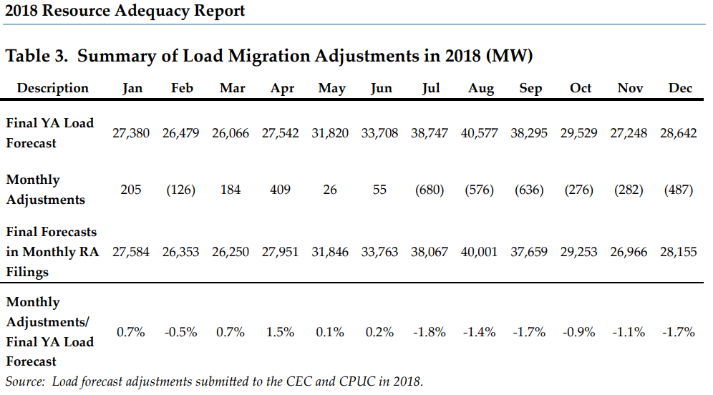
In such cases, which adjustments would the CAISO reject and for which LSEs? Will the CAISO reject such adjustments prior to LSEs submitting showings or after the T-45 timeframe? What are the implications of either scenario? Will the CAISO have LSE RA requirements that is different from what the LRA has allocated?
If an LSE submits its RA showing and is not deficient, but then the CAISO modifies the RA requirements for that LSE, does the LSE face penalties for such a deficiency?
Will the CAISO make decisions for Capacity Procurement Mechanism designations based on these deficiencies at the CAISO even though the LRA may have deemed the LSE to be compliant? If so, how would the CAISO allocate the costs of the backstop procurement?
SDG&E requests the CAISO should provide an impact analysis based on actual LSE filings for this PRR.
Thank you.

https://www.cpuc.ca.gov/uploadedFiles/CPUC_Public_Website/Content/Utilities_and_Industries/Energy/Energy_Programs/Electric_Power_Procurement_and_Generation/Procurement_and_RA/RA/2018%20RA%20Report%20rev.pdf

